**REPORT FOR PORTFOLIO**

**Executive Summary**

This paper presents the development of a professional computer science portfolio that showcases technical skills, education, and experience with projects. The portfolio is hosted on GitHub Pages (GitHub's free website hosting service) and supports a functional student application by providing links to the project repositories, a LaTeX CV, and a structured personal webpage. The project focused on using version controlled by Git and GitHub for the version control of a website that could be designed with HTML5, CSS3, along with optional Bootstrap or Tailwind. The main design consideration was a clean and responsive style which met or exceeded industry standards. The paper reveals the layout of the website and repository, the reasoning behind various design and technology choices, and a critical reflective discussion of the advantages, disadvantages, and possibilities for future updates to the site. Overall, this project has demonstrated the importance of maintaining an online presence and version controlled technical documentation as key elements to continuing development and a career in computer science.

**Table of Contents**

Introduction 4

Portfolio Website 5

Structure of the Portfolio Website 5

GitHub Repository Structure 7

Design Decisions 8

Technologies and Tools 10

The Reflections 11

Conclusion 12

References 14

# Introduction

This portfolio serves as a comprehensive representation of computer science technical capabilities and was tailored for an applied student application. The portfolio aims to specifically highlight the candidate's academic background, practical skills, and knowledge in several computer science disciplines including but not limited to database administration, web development, programming, and data analysis. It does so in an orderly, eye-catching presentation that displays a basic professional resume, some select projects, and other relevant technical artifacts.

The portfolio is codified/hosted on GitHub Pages, designed to be functional, simple to use, and visually appealing. The portfolio provides potential employers with a concise but rich representation of the candidate's academic achievements, technical skills, and professional interests. In addition to a downloadable CV rendered by LaTeX, the portfolio has short summaries of some noteworthy projects with links to GitHub repositories, along with classifications of skill sets that include multiple achievements. While the portfolio shows technical capabilities, it also shows how the applicant demonstrated the use of those skills in real-world application.

The report that accompanies the portfolio, will articulate the design considerations and design decisions made to create the portfolio website. It describes how the homepage and the GitHub repository are designed and what information they contain, gives reasons for selecting specific technologies and tools, and assesses the positive and negative aspects of the results. It also highlights potential areas for adding features and enhancing the project in the future. To meet the standards of professional presentation and proper documentation, this document offers a technical overview as well as a careful explanation of how the portfolio was created.

# Portfolio Website

## Structure of the Portfolio Website

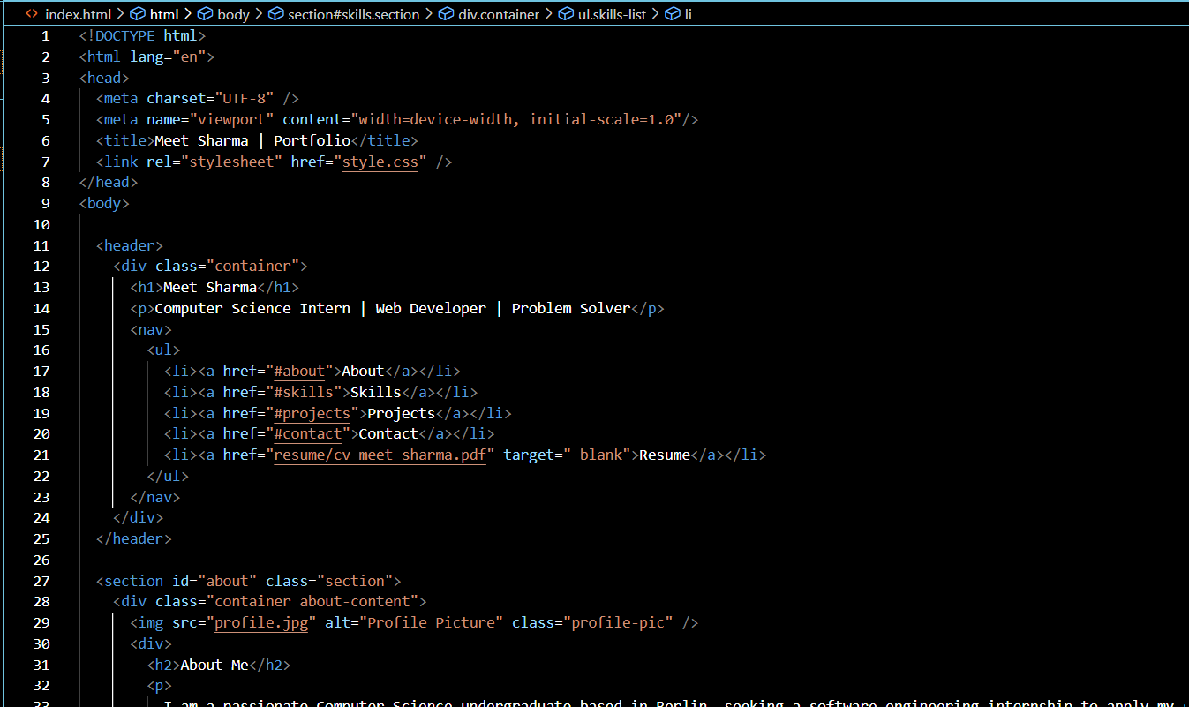

**Figure 1: HTML code**

**(**Source: VS Code**)**

The candidate developed a portfolio website that serves as a brief, yet elegant showcase of their technical ability, educational background, and project work experience in computer science. The website was created with HTML and CSS and has a simple and flexible layout working across a range of browsers on a variety of devices (Frain, 2022). To make information more accessible for getting around the site, the pages are divided into several user-friendly parts.

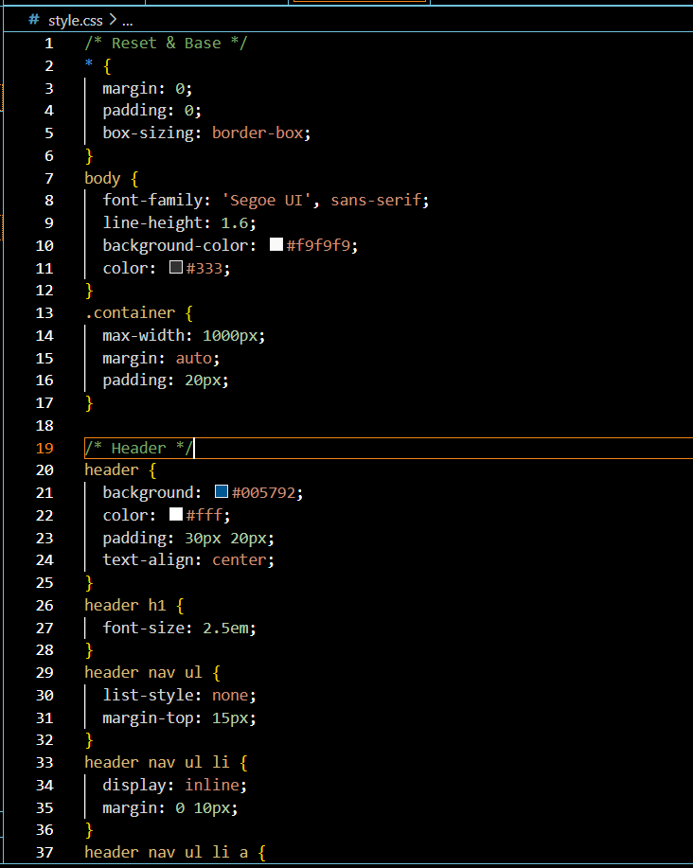

**Figure 2: Css code**

**(**Source: VS Code**)**

The homepage follows a section with a navigation menu linking users to the significant parts of the site, that started with a header to display the professional title of the candidate and a short slogan. The next part is the About section, which gives a summary of the candidate's educational and job experience in a broad detail. The About section also includes a short biographical story along with a profile picture to humanize the content.

The Skills section, after that, offers a list of essential technical skills for the candidate such as data-related technologies, software tools and programming languages in an eye-catching summary. Following the Skills section is the Projects section which covers the specifications about some projects that illustrate how technical skills are used in practice.

Each project listing includes a short description, a list of the key technologies used, and a direct link to the relevant GitHub repository for more in-depth source code review.

The Contact section includes relevant contact information: email address, LinkedIn profile, GitHub account. Because of the employer's needs, the navigation bar contains a clear link for downloading the candidate's resume created in LaTeX. The job candidate's portfolio wraps up with a small footer, crediting themselves.

## GitHub Repository Structure

The way the portfolio's GitHub repository is structured demonstrates best-practices for software development and documentation; it includes a single place where you can review all of the materials that are documented or showcased. This included project material, their CV, and even the source files for the website are hosted in of the portfolio's GitHub repository.

The root of the repository includes the following essential components:

* index.html: The primary HTML file responsible for the document structure and content of the site.
* style.css: A standalone CSS file that provides all the visual styling rules applied to the website.
* images: A directory for storing image files for the assets, including the candidate's profile image.
* resume: This folder contains the PDF version of the LaTeX-generated CV available for download and review.
* README.md: A markdown file with a brief overview of the repository, including an overview of setup, the portfolio's intent, and information about deployment.
* .gitignore: A configuration file to prevent tracking unnecessary system and temporary files in the repository.

The correct naming and commenting of every folder and file fosters professionalism, clarity, and ease of maintenance (Hunter, 2020). Now that using the main branch has been selected as the source, the repository is also configured to automatically deploy the website using GitHub Pages. This allows for simple hosting and real-time updates every time a commit is pushed to the repository.

In addition to improving the candidate's technical credibility, being detailed and fully transparent in regards to repository management illustrates a good understanding of web deployment systems, documentation conventions, and version control protocols.

# Design Decisions

The design of the portfolio web site is based on a number of strategic decisions aiming to ensure usability, professionalism and technological relevance (Aguilera Núñez, 2023). These choices were influenced by modern web development standards and industry standards regarding personal portfolio websites as well as the overall goal of providing a perfect user experience to reviewers and future employers.

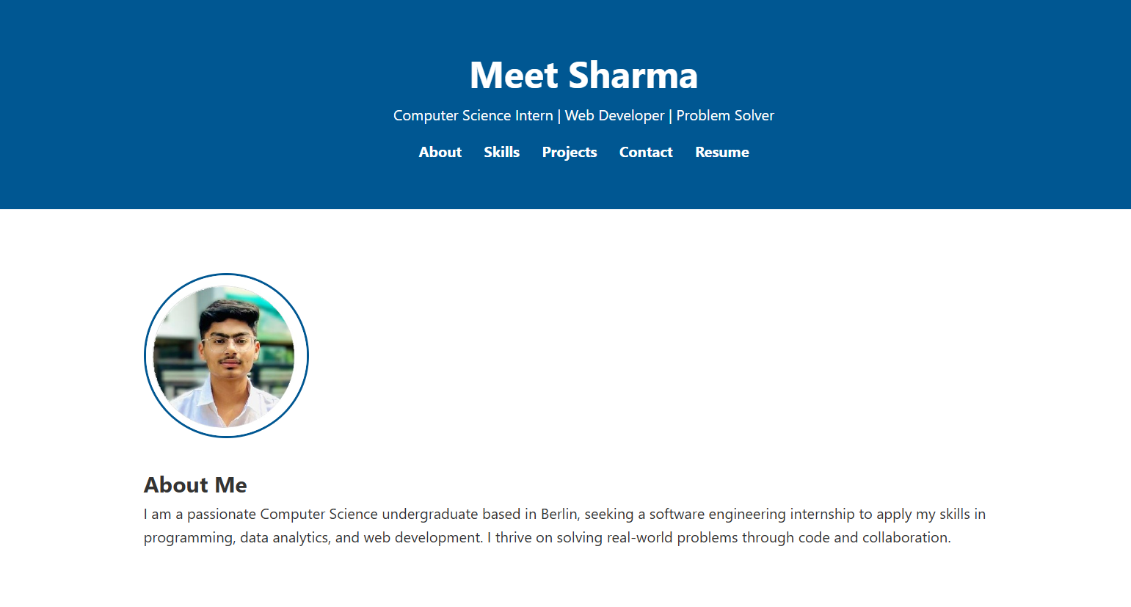

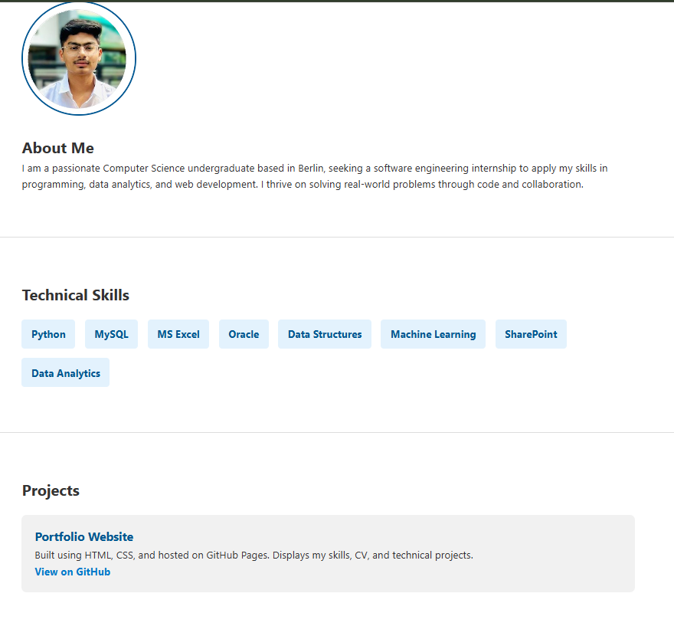

**Figure 3: The webpage of portfolio**

**(**Source: VS Code**)**

One of the key design principles was the utilization of the responsive and uncomplicated layout. By not overwhelming images with the text, the latter remains in the foreground, not only simple and uncomplicated. The responsive design ensures the optimal viewing experience on desktops, tablets, and smartphones, to name only a few of the possible devices and screen sizes. This flexibility enhances usability, as well as accessibility, which is specifically paramount to employers since they might view the portfolio in diverse contexts (Echeverri *et al.,* 2021).

A carefully considered color palette was deployed to create good contrast and visual separation. Readability, and therefore visual interest, was achieved by harmonious, soft background colors combined with rich colors like blue and black for headings and navigation elements. Uniformity in color generates a clean consistent affect which, in turn, helps to establish visual hierarchy of information.

The site employs a familiar structure of accepted best practice, building personal portfolio sites in the technology space. Sections (About, Skills, Projects, Contact, and downloadable CV) are logically ordered and clearly presented to assist the visitor in traversing the content in a natural flow. Navigation is affixed and presents an option at any point within the website for intuitive basing of any engagement.

GitHub Pages serves well for hosting due to low-cost, stable, and ease of deployment (Rajendran *et al.,* 2023). It allows for easy integration and continuous update by offering free static website hosting directly from a GitHub repository using a simple git process. Furthermore, it highlights experience with open-source deployment tools and version control can showcase alignment with current development standards.

Overall, design choices demonstrate an explicit attempt to balance functionality with simplicity to ensure that the portfolio is not only a visual delight but also technically competent.

# Technologies and Tools

The development of the portfolio involved a number of standard tools and technologies of the industry each of which has been selected to serve a particular purpose in the conception, style, documentation and implementation of the project. The following resources were utilised to ensure a firm, professional and viable outcome:

* ***HTML, CSS:*** portfolio website was organized and designed with HTML5 and CSS3 which are web fundamental technologies. Whereas CSS3 entered the possibility to modify the visual elements such as font, colors, spacing, and responsiveness, HTML5 provided a logical and reachable structure. They acted as the foundation block of the user interface of the site (Wikle and Williamson, 2024).
* ***GitHub and GitHub Pages:*** Version control System GitHub was used to manage the project repository, and track changes. GitHub Pages were used to host the site because it is a fast and simple method to serve static content directly out of the source. This mix ensured ease of collaboration, transparency and delivery track records.
* ***LaTeX (Overleaf):*** Our project report and resume were professionally typeset and formatted by LaTeX. Overleaf is a cloud-based LaTeX editor that provided versioning capabilities, real-time collaboration, and simple PDF creation. This decision demonstrated both scholarly presentation standards and careful attention to detail.
* ***Visual Studio Code (VS Code):*** The primary integrated development environment (IDE) we used to create and edit HTML and CSS files was Visual Studio Code (VS Code). VS Code features, such as live server preview, syntax highlighting, and Git integration, greatly enhanced workflow efficiency and productivity.

These utility-first CSS frameworks could have been combined to ensure responsiveness and increase layout development speed (Nandan *et al.,* 2024). These frameworks provide utility classes and components that conform with up-to-date UI design standards to improve consistency across different devices and enhance user experience.

Overall, these resources helped create a portfolio that is maintainable, visually appealing, and technically sound.

# The Reflections

***Strengths***

Looking back at how I created and developed my portfolio, I have accomplished several aspects in terms of look and functionality:

* **Clean and Professional Look:** The stripped down design and calming palette, made it easy to read along with elegant aesthetics. The hierarchy of information is similar to industry standards so my web portfolio looks polished and credible when applying for jobs and for networking with others on a professional level (Minenko, 2025).
* **User-Friendly and Mobile Responsive:** One of my main achievements was to create a responsive design. It looks good and functions well on both a desktop interface and a mobile one, so hiring managers and visitors will be able to easily review the relevant content on any screen size.
* **Effective Project Showcasing:** Every project on my portfolio has a short description and a hyperlink to the relevant GitHub repository. With the ability for users to see my work described at a high level and in its technical depth, my portfolio can be more than just a one-dimensional résumé; it can be an interactive representation of what I can do.
* **Version Control and Hosting Best Practices:** Using GitHub and GitHub Pages has given me the opportunity to practice version control and create a clean, tracked development history. This will replicate many of the real-world workflows of software development and reinforce my knowledge of deployment tools.

***Weaknesses***

Although I am pleased with the outcome, there are a few aspects that can be improved and added going forward:

* **Limited Project Content:** Currently, there are not many projects on exhibit. I plan to add more complex and varied projects (including group work), to provide a more comprehensive view of my skills in multiple areas (data science, full-stack programming, and machine learning).
* **Lack of Advanced Features:** As of now, the website serves simply as a static front-end portfolio. Planned improvements will range from a blog section to provide technical thoughts, and potentially some type of backend integration for dynamic content or user feedback forms.

***Future Improvements***

**Blog Integration:** Asbecause of the intended improvements, I will include a blog component as part of the portfolio. This is where I will post my thoughts on technology, as well as code tutorials and experiences during the development of projects. Overall, in addition to diversifying the content, a blog shows that you are engaged in ongoing learning, have thought-leadership, and communication skills-which are all highly valued in IT.

**Contact Form Feature:** The portfolio currently shows static contact details. We will be adding a dynamic contact form to allow better user interaction using either JavaScript or a serverless solution like Formspree or Netlify Forms. This feature will allow users to directly submit questions to the portfolio and will increase the professional useful and interaction built into the portfolio.

**Expanded Project Display:** Another big enhancement will be more varied projects and interactive demos (Fan *et al.,* 2021). These could include machine learning models embedded as part of the site, data visualizations, or live web apps. This will give viewers and recruiters a better sense of technical ability in a concrete form.

**Light/Dark Mode Theme Toggle:** Accessibility and user customized functionality are particularly important and the portfolio will utilize a light/dark theme toggle to facilitate this. This feature is a kind of built-in logical function in that it aids in readability for a range of viewing preferences, while being more contemporary design-wise.

This next project will take the portfolio to a relatively complete, dynamic, and engaging product.

# Conclusion

This project portfolio has provided as a perfect opportunity, as it allowed for the combination of technical theory and either 'theoretical scenarios' or practical implementations. Each of the assignments has produced meaningful products and has reinforced and developed some valuable skills in web development, version control, and professional writing.By creating a neat and engaging portfolio along with its documentation, the applicant has shown a solid grasp of front-end tools, Git methods, and the practical application of LaTeX in both school and work settings.

The maintenance of a technological portfolio is increasingly becoming important in computer science. It serves as an active display of the capabilities of an individual and allow future employers immediate availability to technical content, real-world projects and demonstrations of the application of skills. Compared to a typical resume, a portfolio allows a higher level of interaction and provides functional and visual evidence of the candidate and his or her talents and progress.

Besides enabling version control and deployment processes to be more useful, the use of GitHub and GitHub Pages demonstrated the importance of a solid online presence. These sources play a decisive role in the demonstration of technical literacy and professionalism in a sector where cooperation, openness and constant evolution are at a premium.

Altogether, the experience promotes the importance of combining academic learning with practice. The portfolio facilitates a long-term career development in a rapidly evolving profession of computer science and can be considered a professional and personal achievement.

# 

# References

Frain, B., 2022. Responsive Web Design with HTML5 and CSS: Build future-proof responsive websites using the latest HTML5 and CSS techniques. Packt Publishing Ltd.

Hunter, G.S., 2020. Developing and maintaining practical archives: A how-to-do-it manual. American Library Association.

Aguilera Núñez, À., 2023. Design of a strategic plan for the creation of an online education and advisory platform focused on personal finance (Bachelor's thesis, Universitat Politècnica de Catalunya).

Echeverri, N., Jylhä, T. and Koppels, P., 2021. Searching for flexibility in corporate real estate portfolio: Six co-working strategies for user corporations. Buildings, 11(3), p.115.

Rajendran, P., Maloo, S., Mitra, R., Chanchal, A. and Aburukba, R., 2023. Comparison of cloud-computing providers for deployment of object-detection deep learning models. Applied Sciences, 13(23), p.12577.

Wikle, O.M. and Williamson, E.P., 2024. Exploring Static Web in the Digital Humanities Classroom: The Learn-Static Initiative.

Nandan, S., Usha, S.R. and Priyanka, M., 2024. Comparison of Utility-First CSS Framework. Journal of Innovation and Technology, 2024(32), pp.1-6.

Minenko, M., 2025. Reevaluating the Role of Portfolios: Their Influence on Career Success for Junior Software Professionals.

Fan, D.P., Ji, G.P., Cheng, M.M. and Shao, L., 2021. Concealed object detection. IEEE transactions on pattern analysis and machine intelligence, 44(10), pp.6024-6042.